SQL vs. Drupal Views - A Deeper Understanding

Section 19, Lecture 79

SQL vs. Drupal Views - A Deeper Understanding

*SQL* (pronounced "ess-que-el" OR "Sequel") stands for **Structured Query Language**. *SQL* is used to communicate with a database. 

It is the standard language for relational database management systems.

SQL is constructed from simple commands such as: 

SELECT name FROM user WHERE userid = 1 

Such a command is called a ***Query***. This example is from the most common format called the "SELECT Statement". There are other standard statement formats too. 

Such queries will soon get longer and complicated in real life applications. 

DRUPAL VIEWS is a powerful Visual Query Builder.

Drupal Views section is designed upon the SELECT SQL Query - and so, many of the concepts from Views will map directly to the SQL statement. 

Here is an image that shows the basic mapping *(I have used the same View example from previous lesson)*: 

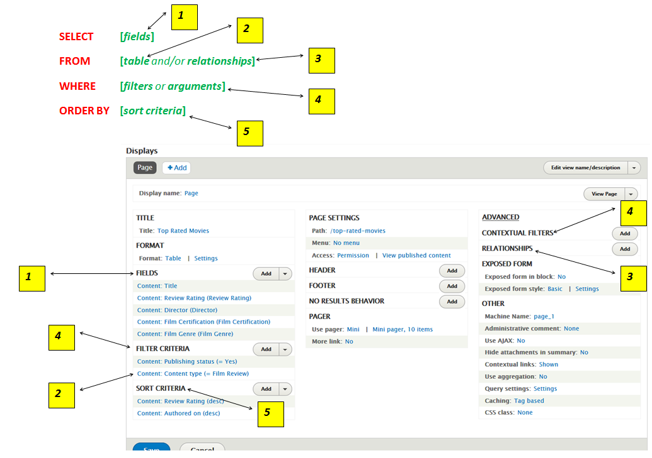  
  
**CONCLUSION:**

* If you are already familiar with SQL - then understanding this mapping will help you construct Views with ease.
* If you are not familiar with SQL - then understanding the Views interface will help you understand SQL better.
* If you are migrating existing code to Views, then also, understand this mapping to make your work easier.